**DESERIALIZATION:**

***Helpers/TestDataHelpr.cs (Education)***

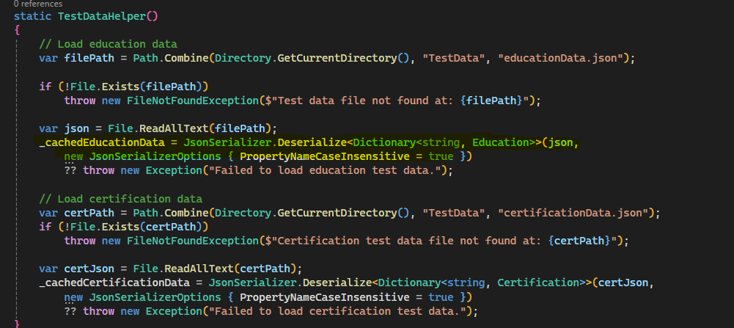

StepDefinition calls GetEducationData(dataKey) : *sample dataKey is “validEducation”*

Education Test Output:

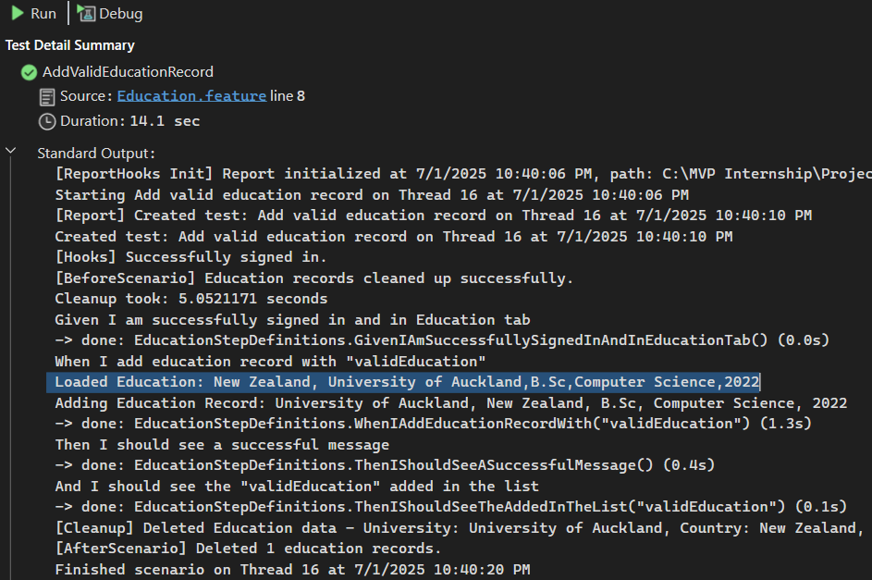

***Helpers/TestDataHelpr.cs (Certification)***

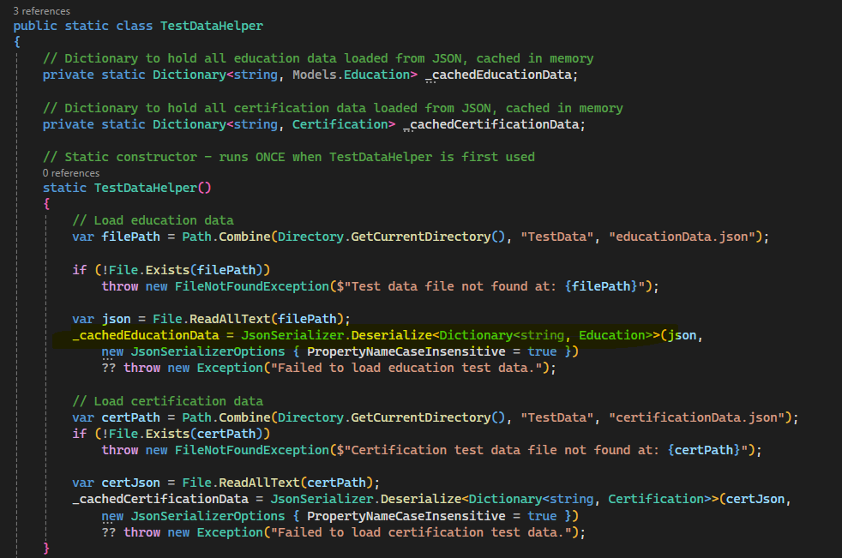

Sted Definition calls GetCertificationData(dataKey) : *sample dataKey is “validCertification”*

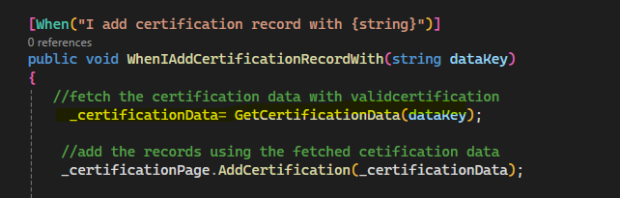

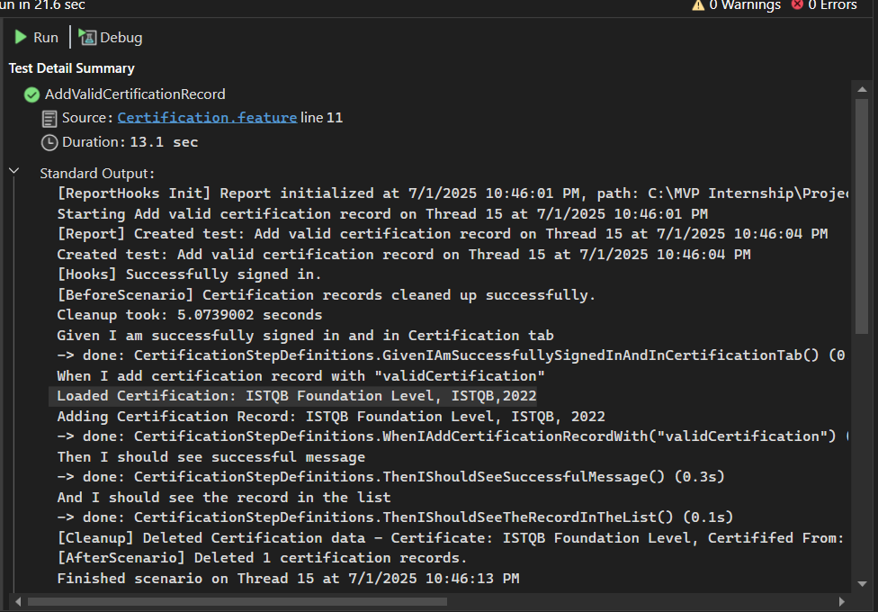

**Education Json file:**

**Education Model class:**

**Certification Json file:**

**Certification Model class:**

